Sporting Clay
2017
Classic Committee
Pat McGavic, Chairman
Roger Redman
Ed Rethlake
Blake Rollins
Richard Holder
Bill King
Ben Blumenberg

Thank you to the 2017
Corporate Sponsors
GMCH
Erik’s Chevrolet
eXmark
Izaak Walton League
McGavic Outdoor Power Equipment
Mid America Beverage Co.
King Oil

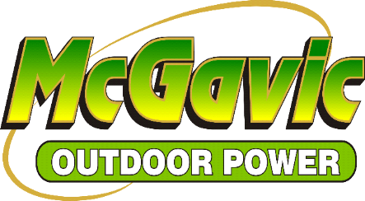

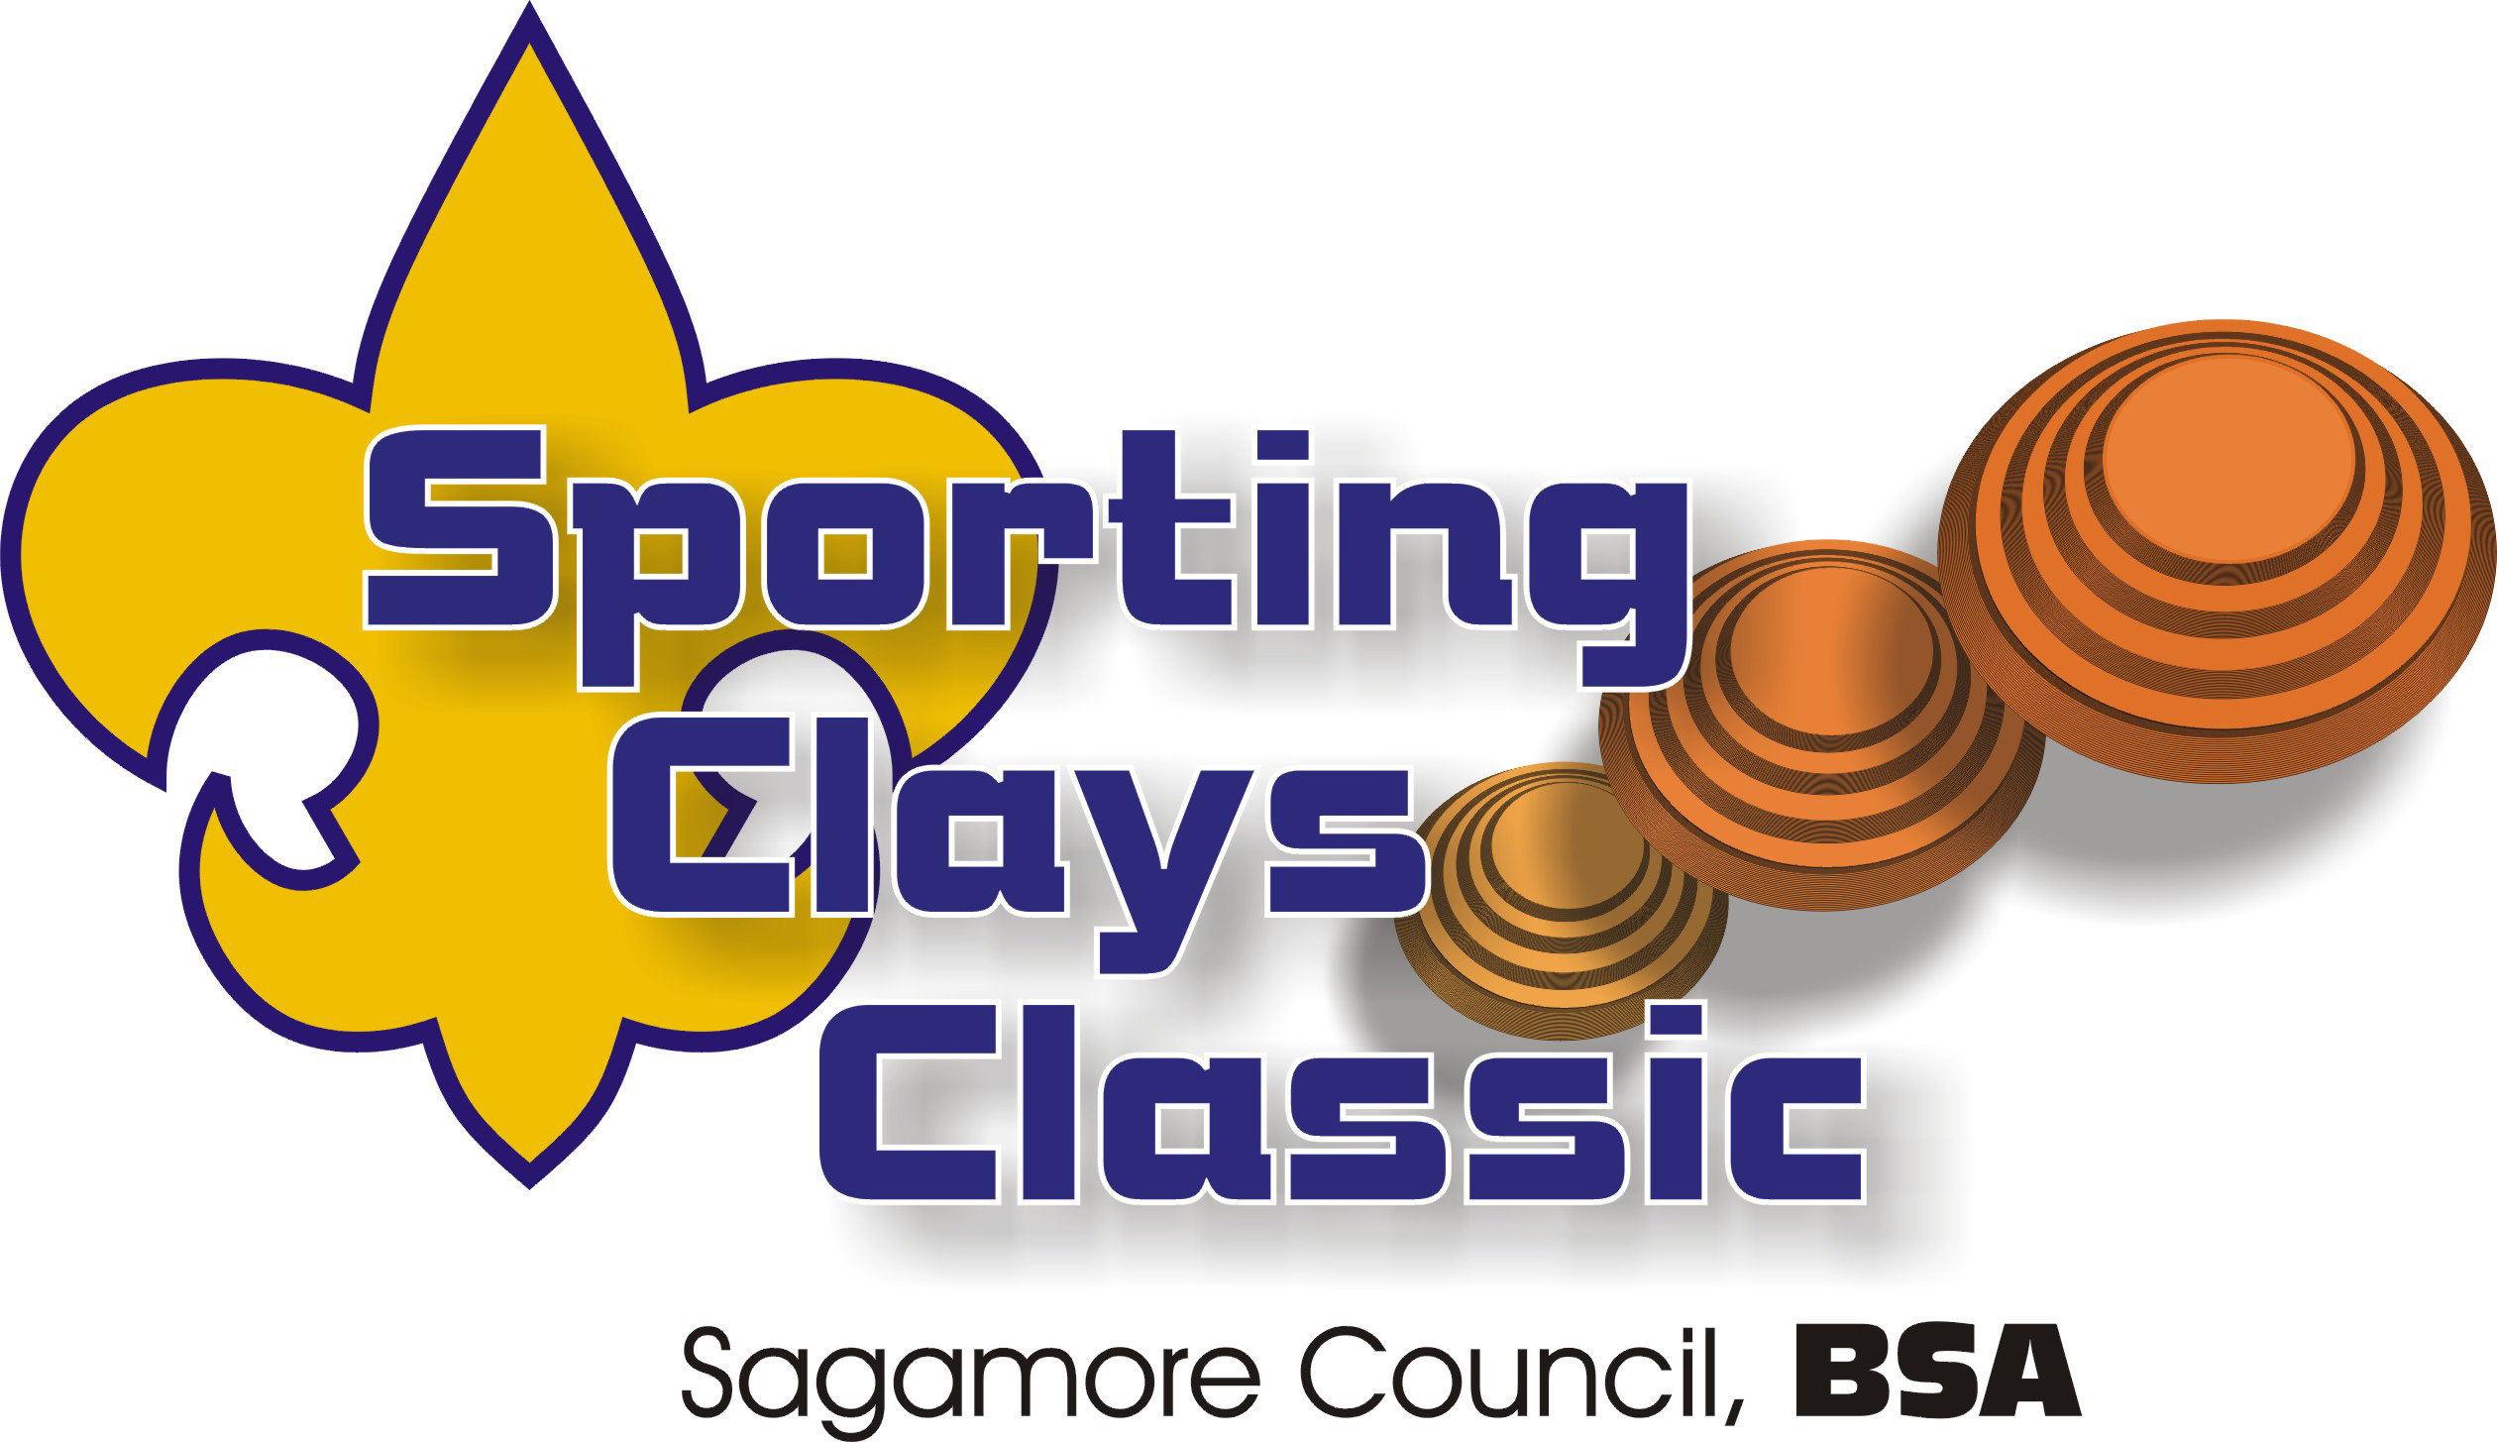

THE MISSION
of the Sagamore Council, BSA, is to serve others by helping them to instill core values in young people and prepare them to make ethical choices during their lifetimes in achieving their full potential.

THE VALUES OF SCOUTING
On my honor, I will do my best, to do my duty, to God and my Country, to obey the Scout Law, to help other people at all times, to keep myself physically strong, mentally awake and morally straight.

A Scout is Trustworthy, Loyal, Helpful, Friendly, Courteous, Kind, Obedient, Cheerful, Thrifty, Brave, Clean and Reverent.

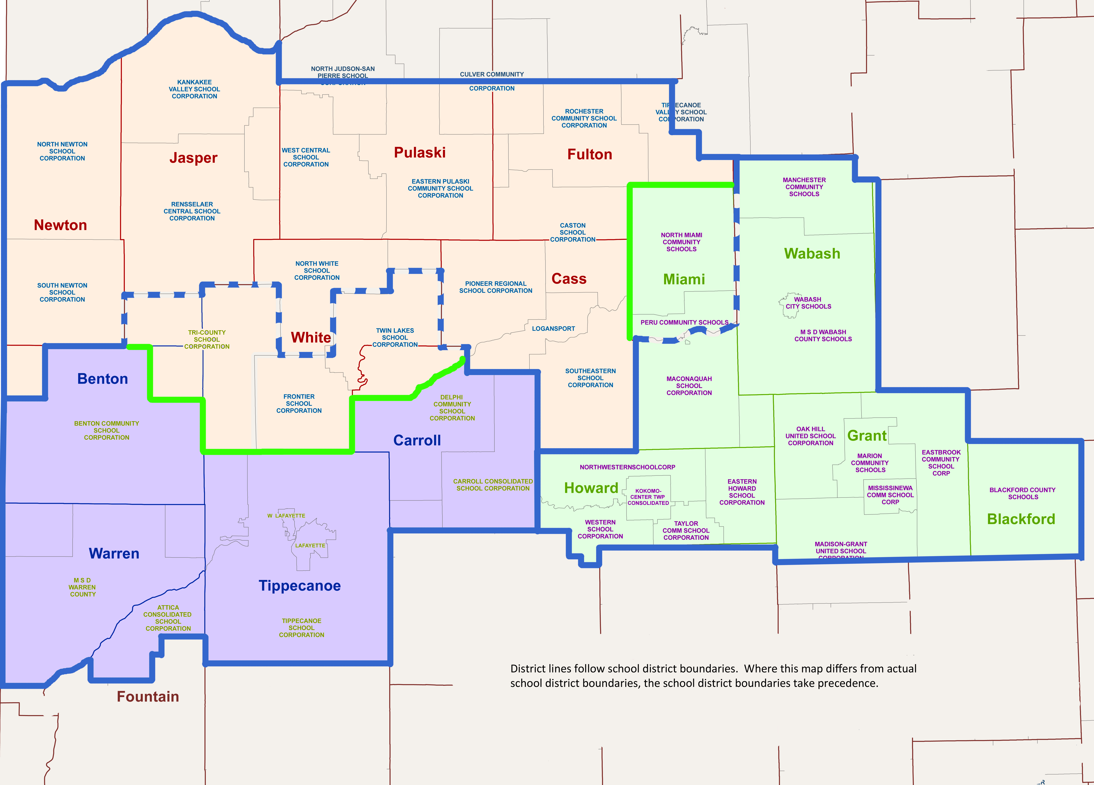

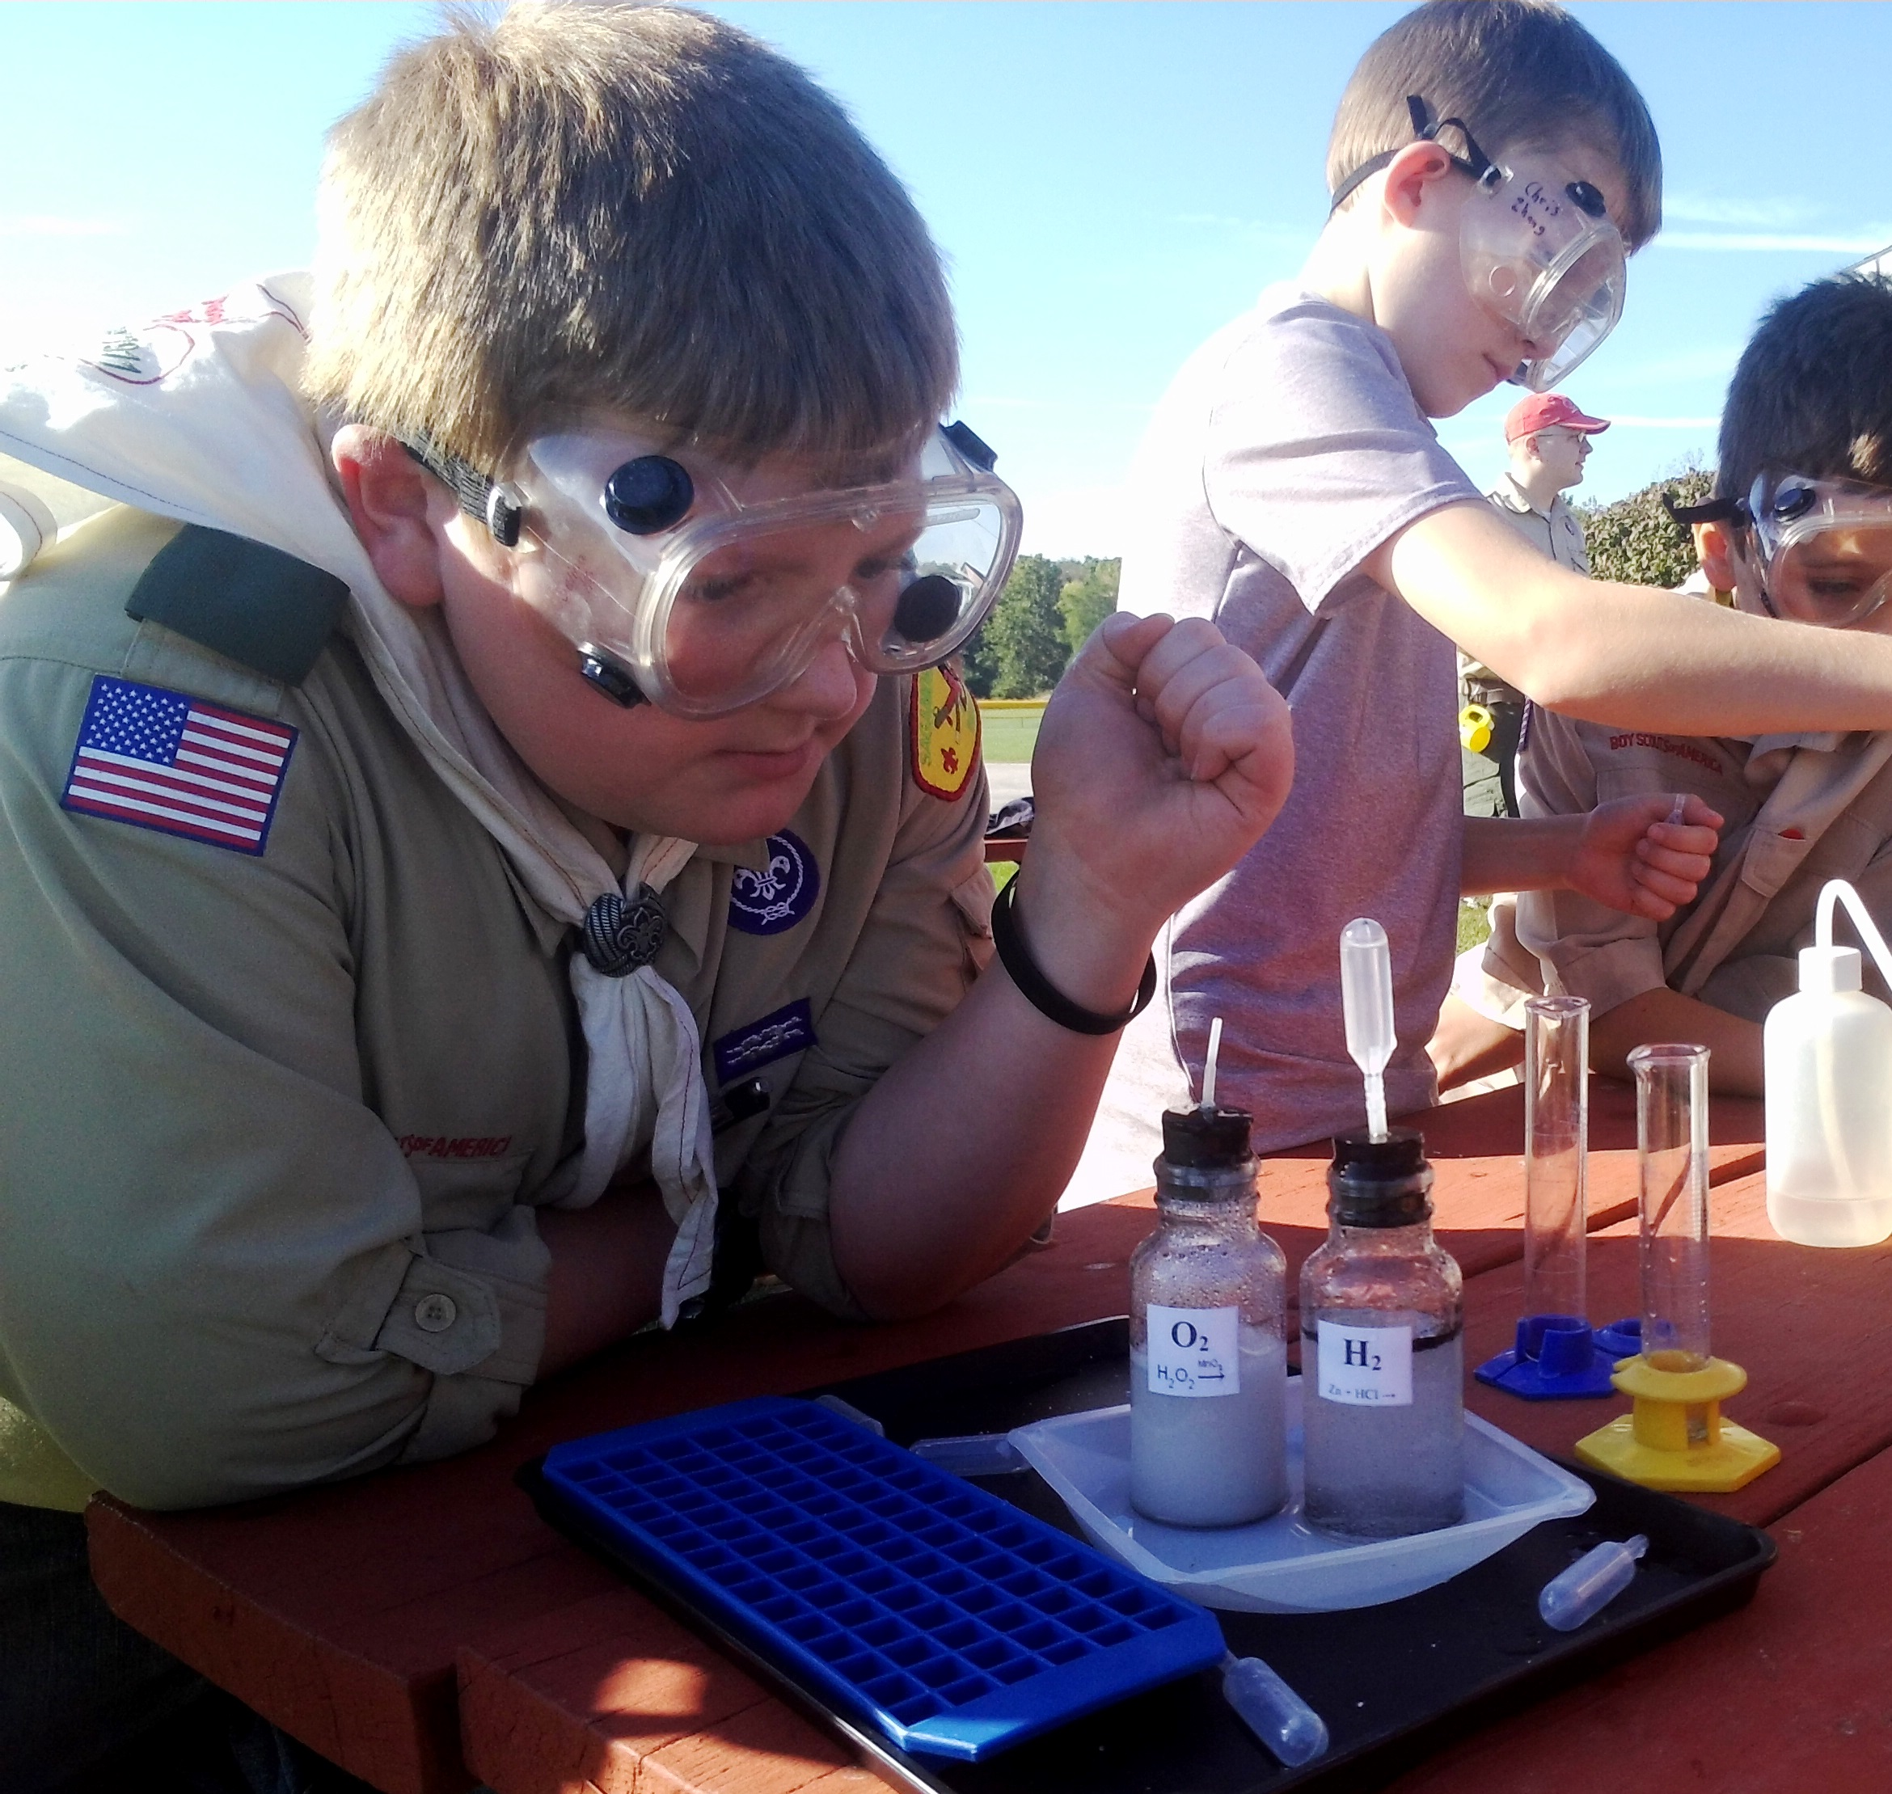

2017 Sporting Clay Benefit Shoot

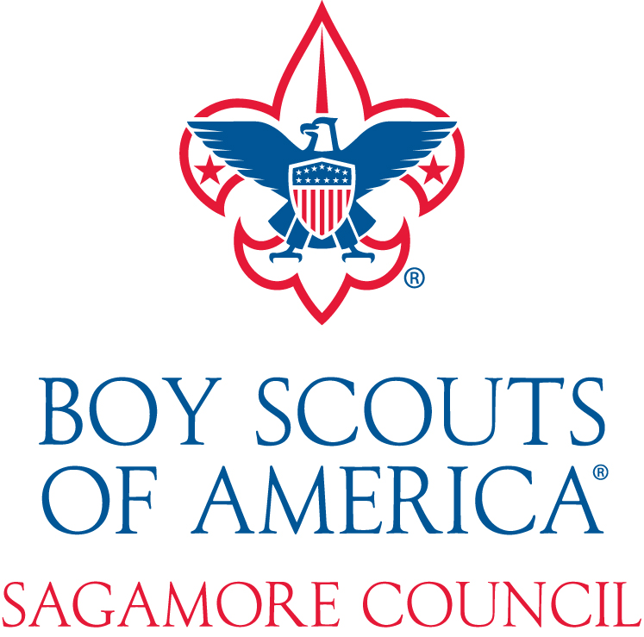

September 23, 2017

Izaak Walton League

Kokomo, Indiana

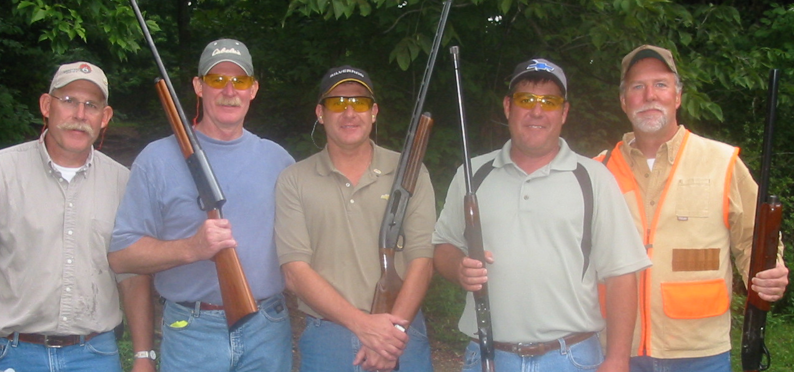

Event Schedule
Saturday, September 23, 2017

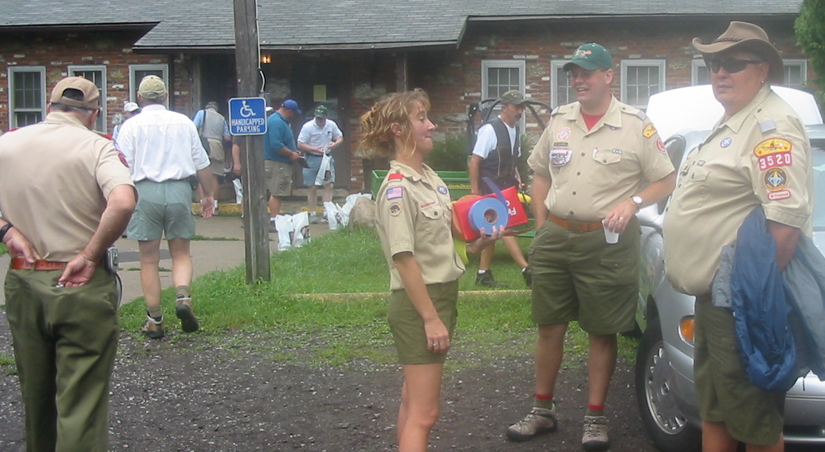

Registration opens 8:15 am

Opening Ceremony
Welcome & Orientation
Safety Talk 9:20 am

Shooting begins 9:30 am

Lunch served Noon

Auction begins 1:00 pm

Bucket auction closes 1:30 pm

Awards & Thanks 1:35 pm

Sporting Clay for Scouting
This event will benefit the 5,885 youth served annually in 16 north central Indiana counties. The Sagamore Council, Boy Scouts of America is pleased to announce its annual Sporting Clay Benefit Shoot for Scouting. We are now seeking additional corporate sponsors, prize donors, shooting teams, and individual supporters for this event. Please consider participating in what will be a truly great, fun, and safe event.

Sponsorship Giving Levels

Corporate Team Sponsor $1,000
Five shooters per team (ammo provided) and sign sponsorship.
$1,000 tax deductable
Station Sponsorship $100
Station sponsor sign,
$100 tax deductable
Live & Bucket Auction Donations
Auction donation sponsors will have program printed recognition.

Shooter $100
Shooter (provide own ammo).
$65.00 tax deductable
Sagamore Council, Boy Scouts of America
PO BOX 865
Kokomo IN 46903
765-452-8253 or 800-844-0537
Fax 765-459-5625 or 800-494-5625

Sporting Clay Shoot
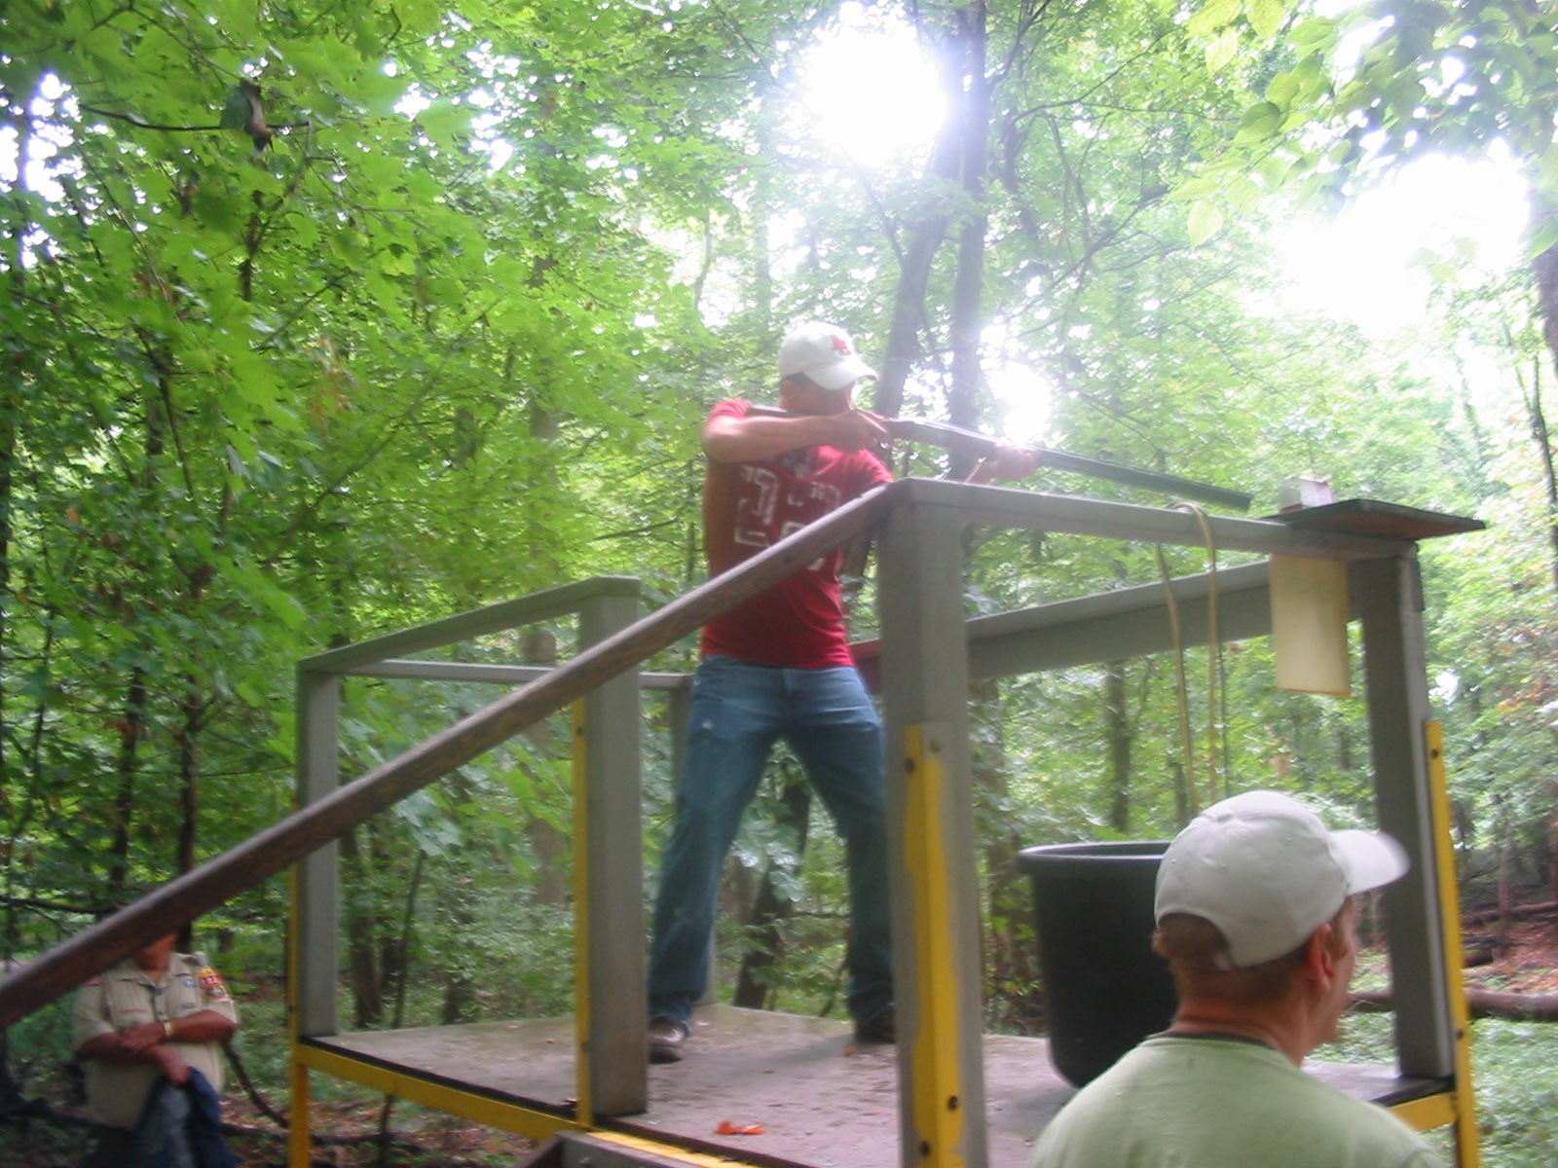
Registration form

Sponsorship Giving Levels

$1,000 Corporate Team

$100 Station Sponsor

Live/Bucket Auction
Donation
Item (s) donated_____________________

Shooter @ $100

___________ x $100 = _______________

Name: _____________________________

Address: ___________________________

City/Zip: ___________________________

E-mail: ____________________________

Phone: _____________________________

Two man flurry _____________ $20 ($10 per person) [one box of 25 shells included per 2 man team]
Method of Payment:
Check Visa
Bill Me Mastercard
Exp. Date__________

Credit Card #

Signature

