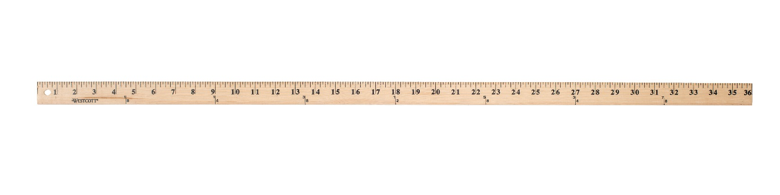
The Yardstick Story

The importance of the ages 7 - 11, the Cub Scout years.
You will need a standard yardstick with colored marks at the 3", 5" 9" and 11" distances from one end. These correspond to the ages of 7, 11, 18, 22.
Look at this yard stick as your son's life. Each _" equals 1 year. Thirty six inches - 72 years, the average person's lifespan. At 0" (1 year) he is cruising the carpet and furniture, getting into all kinds of things he shouldn't. At 3" he's seven and is in first grade, and excited about school. At 5" he's eleven, and is moving on to Jr. High or Middle School. At 9" he's eighteen and graduating High School. You're busting your buttons with pride for him in his cap and gown. At 11" he's graduating college and has moved on to his own life and family.
I'd like to go back to the 2" between 3" and 5" (between 7 and 11 years old). [Hold your fingers at these two marked lines]. These 2", or 4 years are key years in your son's development. Many of his decision-making skills, ethics and morals will be developed and reinforced during this time. A recent study showed that young people who were close to a caring adult in these early years were less likely to get into trouble with drugs, crime, etc. and were more likely to continue in school.
These four years are the years of the Cub Scout. Tiger Cub through Webelos Scout. [At this point drop the yard stick, but keep your finger spaced the 2" apart]. In Cub Scouting we need every family to get involved this much. [refer to the distance between your fingers]. "This much" is different for everybody. Your "This much" might be as a committee member, or a den leader for your son, or for others'. It might be organizing an outing, handling the Pack treasury, writing a newsletter, organizing the Blue and Gold banquet. It might be as a Cubmaster.
[Lift the yard stick again]. If one person tries to do this much the program will surely fail, but if everyone does "This much" in your son's Scouting career both he and you will have a great experience!
So what are you waiting for? Let’s make your son's Scouting Experience something he will remember for a lifetime!
Sign up to help today. Scouting - a family fun experience!

